**Coursework 1 App Design for Preschool Education**

Self Evaluation

Throughout this process I have thoroughly enjoyed every moment in designing my first fully functioning app. I had basic knowledge of swift before the start of this course so I knew how some elements worked, however after this experience I have gained even more knowledge of app development, user requirements and swift as a programming language.

The challenges I faced throughout the development of my app were the auto layout constraints so that the game could function on every iPhone and iPad, as I found it hard to understand what each constraint did to that particular object, which made it very time consuming when altering every objects layout constraint.

In addition to this I found it challenging to implement the constrained movements for the image dragging as it was hard finding example code that worked with the new version of swift 3, however I persevered and managed to understand the code and convert it myself to the newer version of swift.

Usability Reflection

I believe my application offers a rich and unique usability experience to the user. The reasons behind this are that my app has incorporated image-dragging capabilities, where the user can drag apples to gain a visual representation of the sum proposed to them, which aids in further understanding simple addition to a young child.

In addition to this I have incorporated specific button and apple image sizes in order to offer an excellent usability experience. “Apple's iPhone Human Interface Guidelines recommends a minimum target size of 44 pixels wide 44 pixels tall.” (Apple Inc, 2016) So I have therefore given my buttons 67 pixels wide and 68 pixels tall and I have given my apples a width and height of 80 pixels, the reasons why I have made them bigger than the guidelines is because young children may be more inaccurate when tapping the buttons and images, furthermore by having larger buttons and images it will be clearer for the user to see also. Furthermore this app incorporates a minimalistic design with a clean screen layout so not to confuse the young user.

I have added result verification so the user will know if the answer he/she entered is correct or incorrect, I have done this so when the user gets the correct answer he/she will be greeted with the congratulations screen and a positive sound effect to also show that they have got the answer correct. On the other hand when the user gets the answer incorrect the question mark will change colour to red and animate for 0.5 seconds as well as produce a negative sounds effect so the user knows its incorrect.

I have added happy, catchy background music within my application in order to attract the young user to keep using the app for long periods of time and for the user too not get bored of the app quickly. “It can serve to enhance a sense of immersion, enhance the sense of aesthetic continuity, and cultivate the thematic unity of a video game”. (Zhang J, Fu X, 2015).

I have also implemented auto layout constraints to objects within my application; this is so the app will run on every iPhone and iPad device, and make the app more accessible to a wider range of users. So when the app runs on an iPhone 6s Plus all of the proportions are set and will fit the screen perfectly, when I run it on an iPhone SE which has a smaller screen the app auto adjusts to the layout of the smaller phone screen which benefits users who have older or new iPhones or iPads.

After reflecting over the usability of the app I believe that this app has excellent usability as it conforms to many devices, implements audio components, having the option to move objects freely within the app as well as having button interaction for the user, all these elements combined produce a fun learning application which isn’t too complicated for young children.

Future Improvements

For the future improvements of my app I would add a scoring system so that users can attempt to beat previous high scores, this would add a more competitive element, which would then engage users and increase user retention.

In order to keep users engaged and increase user retention I would create incentives in order for the users to keep playing the game. I would implement a rewards system so when the user gets 10 correct answers in a row they would get a bronze medal and if they get 30 they would get a gold medal etc.

The final improvement I would include would be to add a more advanced versions/levels of the game for older users. For users who have grasped the basics of addition I would then include a subtraction, divide and multiplication level so that users can practice other areas of mathematics other than basic addition.

Trello Usage

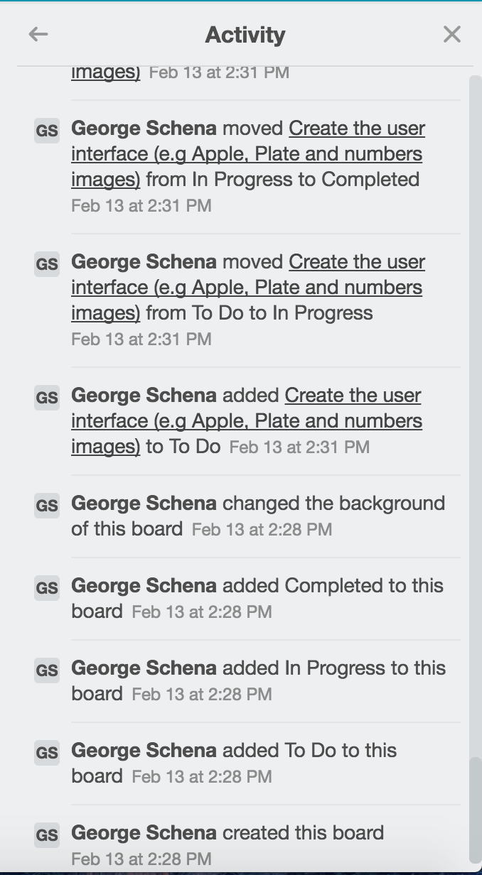

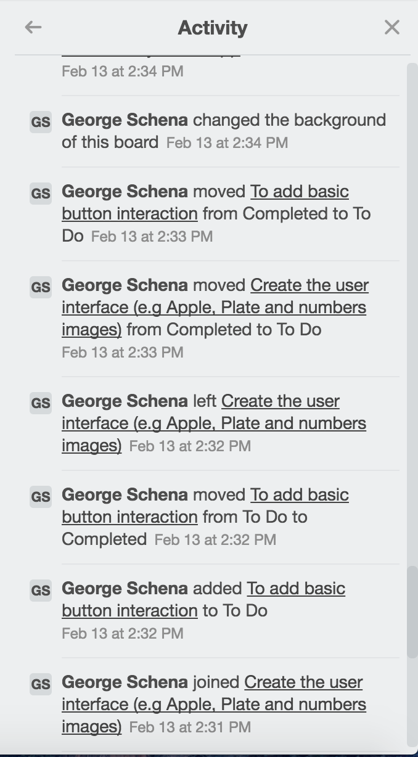

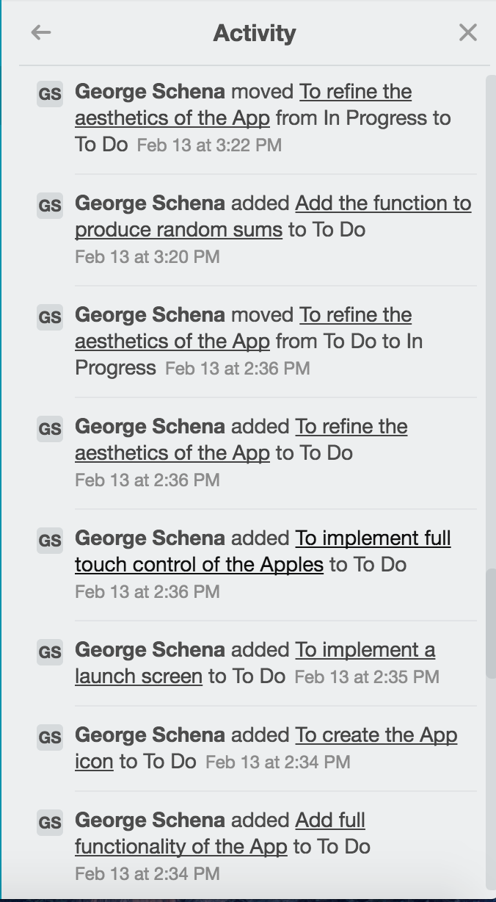

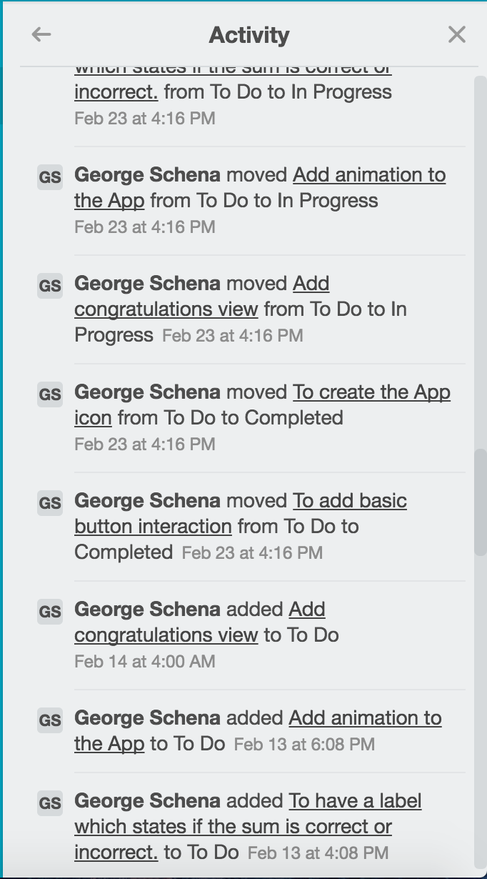

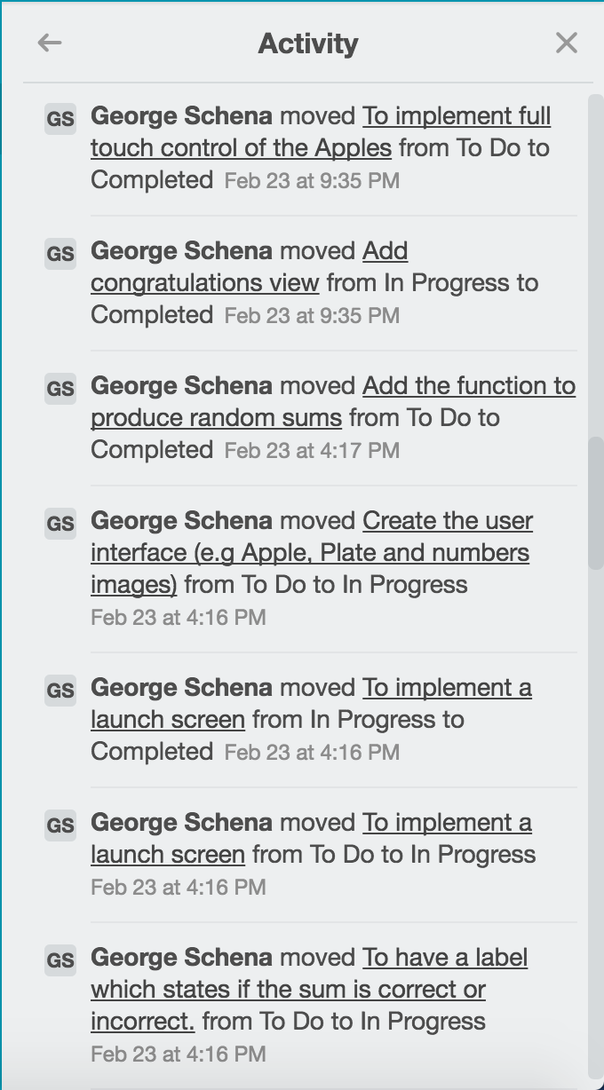

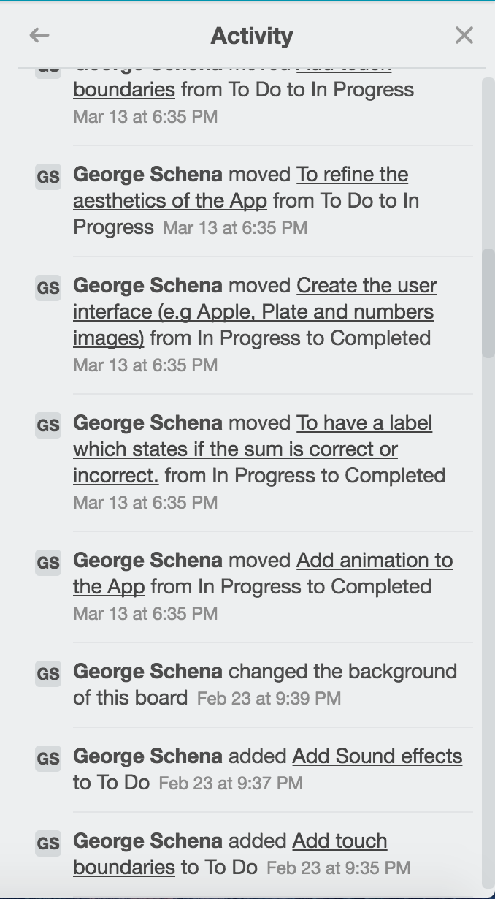

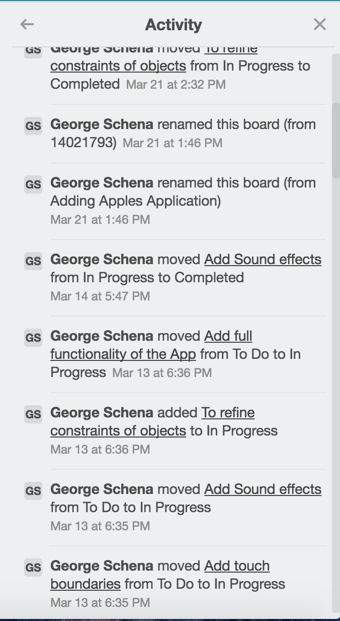

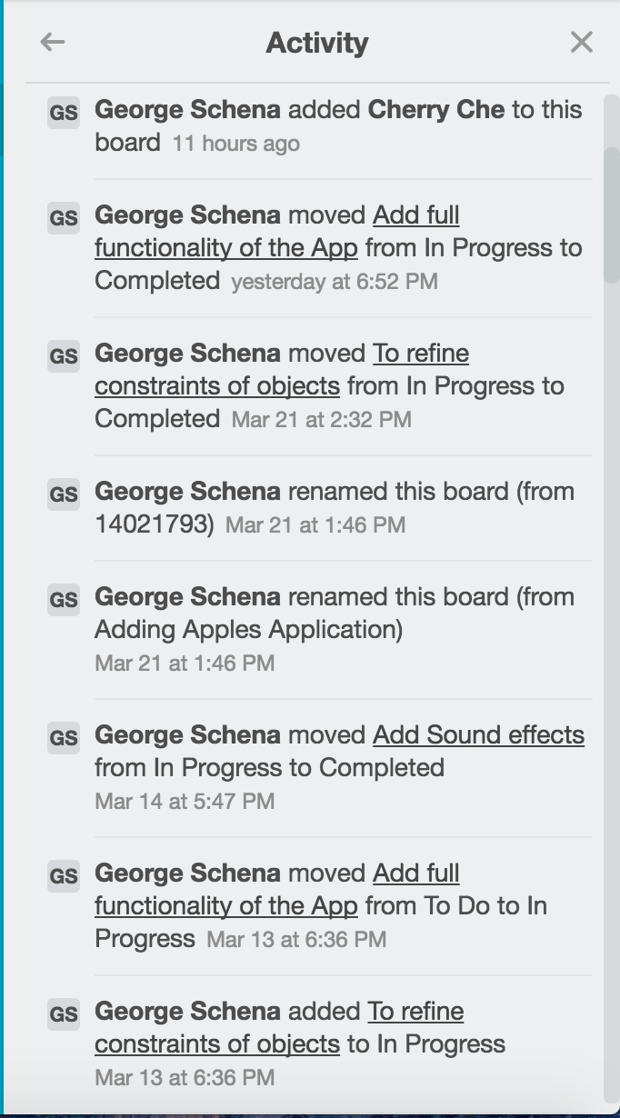

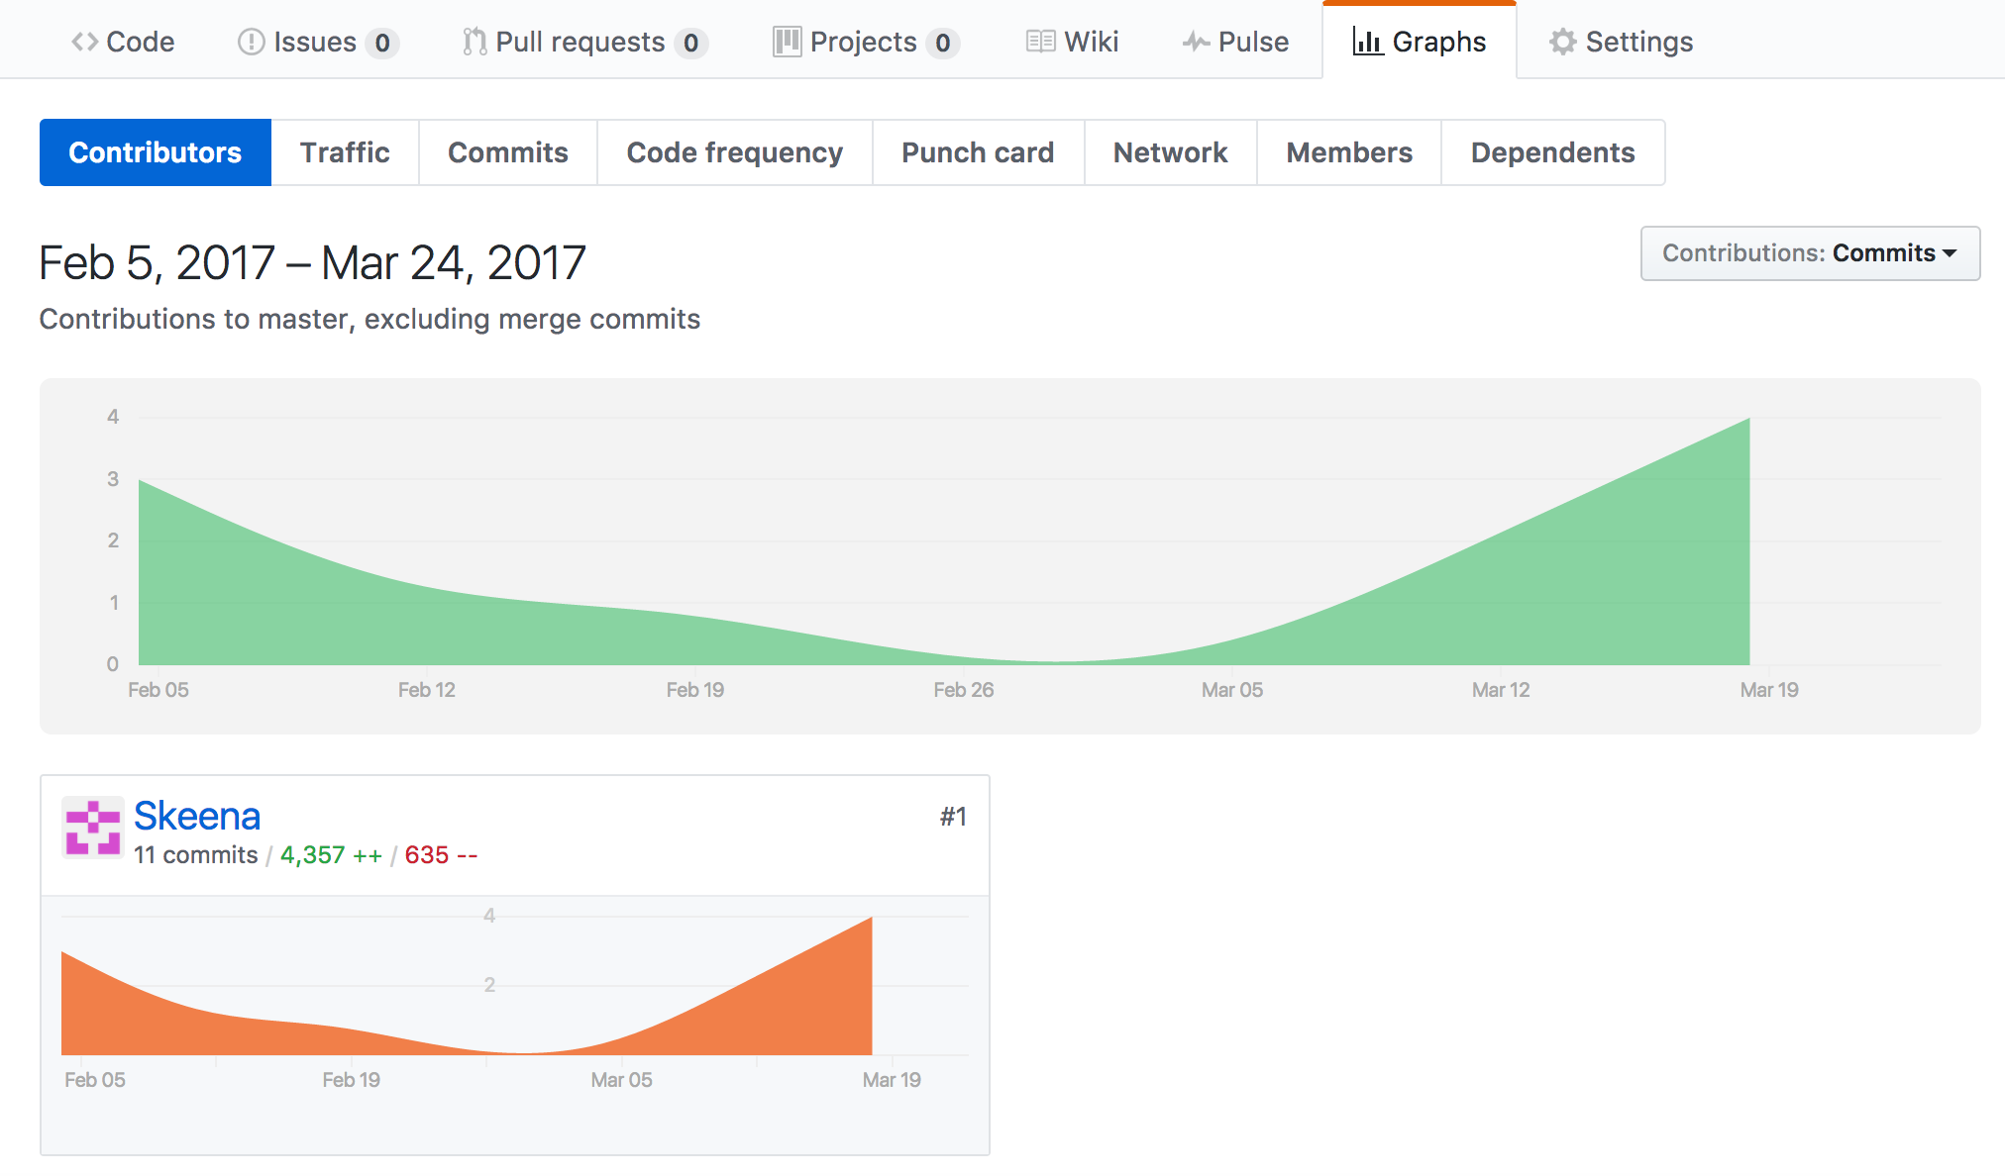GitHub Usage

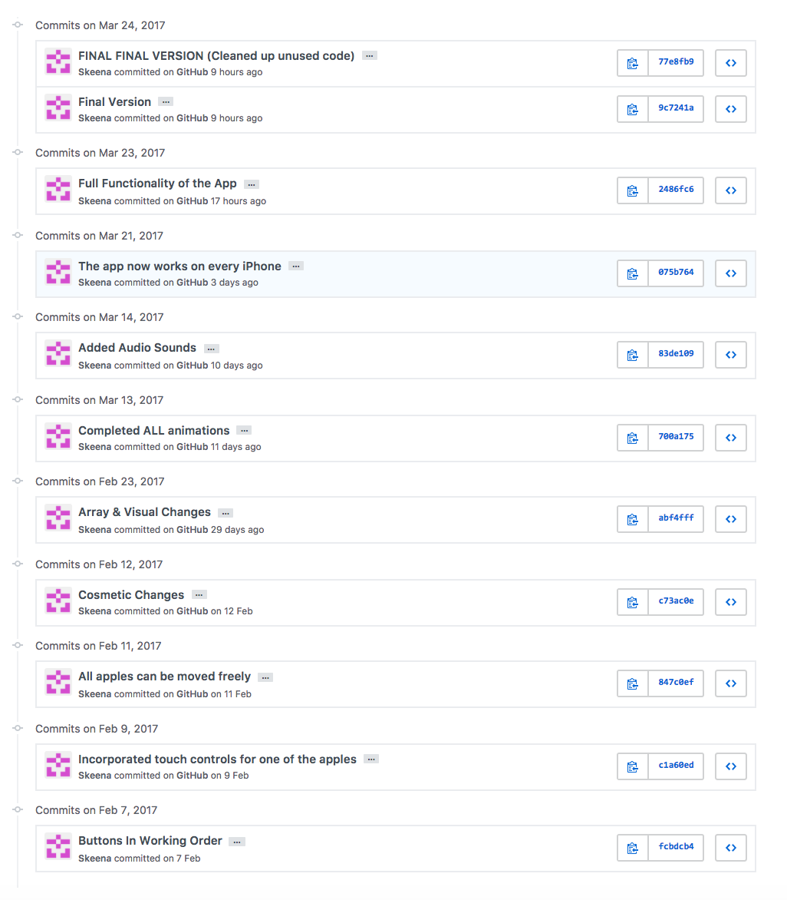Feb 7: Firstly I made sure that the buttons functioned correctly

Feb 9 – Feb 11: I then made sure all the apples could move freely

Feb 12 – Feb 23: I made minor cosmetic changes such as adding a background and making the app look appealing as well as organizing as well as changing the way the game generates random sums.

Mar 13 – Mar 23: I completed all the animations I wanted in my app such as the starts, and the question mark when an answer is wrong. And made the app compatible on every iPhone. I went the step further to also implement background music and button sounds.

Mar 24: Refining the code and making final adjustments such as image placements, cleaning up unused code and making it look appealing.

References

* Xiaoqing Fu, Jiulin Zhang. (2015)"The Influence Of Background Music Of Video Games On Immersion".[ONLINE] Avaliable at: [*https://www.omicsonline.org/open-access/the-influence-of-background-music-of-video-games-on-immersion-2161-0487-1000191.php?aid=58693#6*](https://www.omicsonline.org/open-access/the-influence-of-background-music-of-video-games-on-immersion-2161-0487-1000191.php?aid=58693#6). [Accessed 16th March 2017]
* Design Principles – Overview – iOS Human Interface Guidelines. (2017). Design Principles - Overview – iOS Human Interface Guidelines. [ONLINE] Available at: <https://developer.apple.com/ios/human-interface-guidelines/overview/design-principles/>. [Accessed 16 March 2017].